Universal Serial Bus Tutorial

1) Identify the following USB connector types and where they are used?

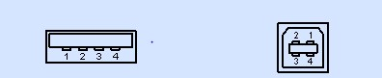

i) Type A ii) Type B

Type A usage- This type is the more using type used in USB flash drive and many things

Type B usage- used in many printers

and Arduinos

2)

1. What is the use of pull up resistors in USB cables?

The pull up resistor is used to detect the presence of the connected device by the host. If no pull up resistor is connected, host assume that nothing is connected.

1. How does a full speed and low speed device use the pull up register?

Location of the pull up resistor is used to identify the speed, if it is connected to the (-D) while it is connected to the (+D) in high speed.

3) What is the purpose of an endpoint zero and why is it so important?

4)

|  |  |  |  |  |  |
| --- | --- | --- | --- | --- | --- |
| 01010001 | 11010010 | 11111111 | 1010 | 01001 | EOP |

i)What type of packet is represented above? Explain how you came with the conclusion ii) What is the maximum number of devices supported by USB? iii) Based on the packet structure is this High speed or a low speed device?

1. Why are there no retries of sending packets in Isochronous transfers?

1. Below are three stages of control transfers. Identify them and describe the process of each of them?

i)

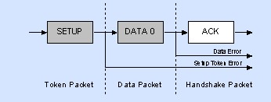

ii)

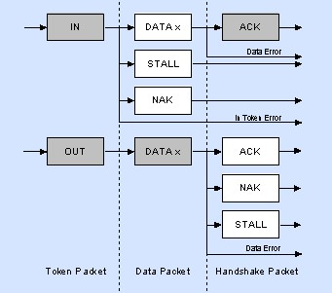

iii)

